IPL 2022 Data Analysis Report

Introduction
This report presents an analytical overview of the Indian Premier League (IPL) 2022 season using match-level data. The objective is to extract meaningful insights that can help stakeholders such as team management, analysts, and broadcasters understand team performance, match outcomes, and key influencing factors.Exploratory Data Analysis (EDA)

Matches by Stage
- Majority of matches were played in the League stage.
- A smaller number of high-pressure matches occurred during Playoffs and Finals.

Toss Analysis
- Teams winning the toss preferred fielding first in most matches.
- Chasing teams showed a slightly higher win percentage compared to teams batting first.

Match Result Analysis
- Matches were won both by runs and wickets, with chasing victories (wickets) being more common.
- Close-margin matches (less than 10 runs or 2 wickets) highlight competitive balance in the tournament.

Team Performance Insights

Batting First vs Chasing
- Some teams performed better when defending a target, while others were stronger while chasing.
- High first-innings scores generally increased win probability, especially above average scores.

Consistency
- Top-performing teams showed consistency across multiple venues.
- Lower-ranked teams showed performance fluctuations based on venue and toss outcome.

Venue Analysis
- Certain venues recorded higher average first-innings scores, indicating batting-friendly conditions.
- Some grounds favored chasing due to dew and pitch behavior.

Player of the Match Analysis
- A small group of players won multiple Player of the Match awards.
- These players contributed significantly either through match-winning innings or bowling spells.

Research Questions Analysis

Which team won the most matches?
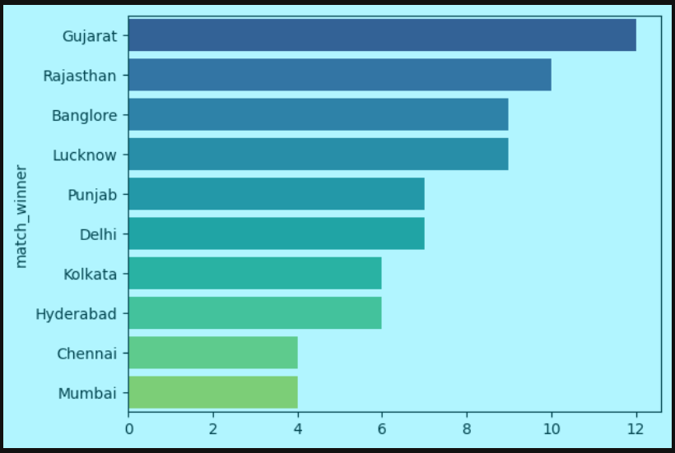
Most Matches Played by Venue?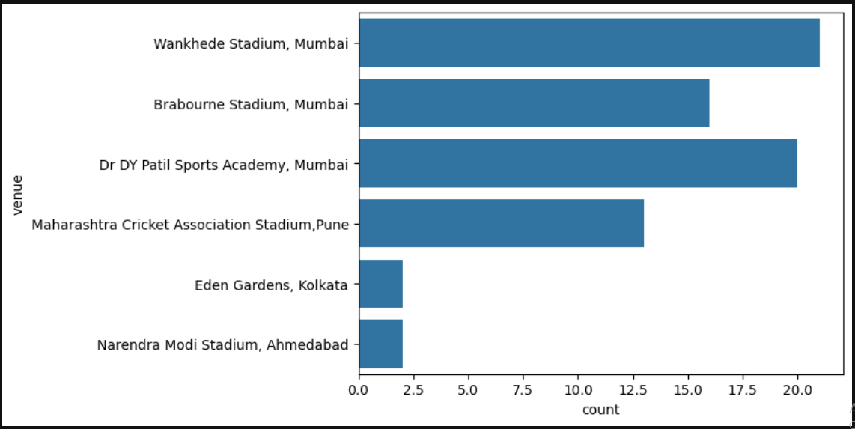
Top Scorers?

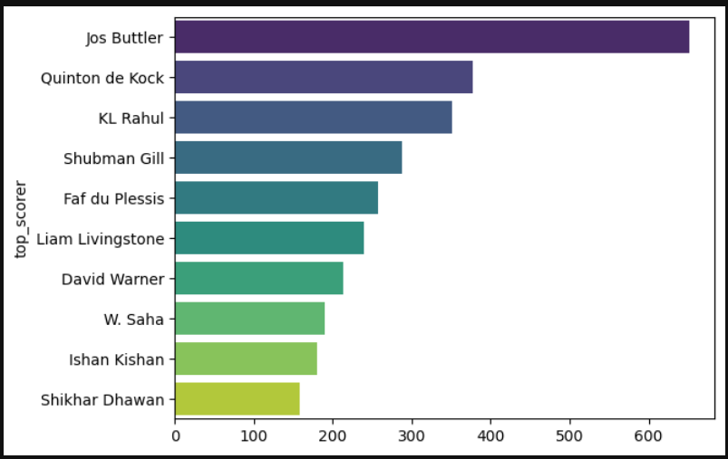

Conclusion

IPL 2022 was a highly competitive season with balanced performances across teams. Data analysis reveals the importance of toss decisions, venue conditions, and individual contributions. These insights can be leveraged for strategic planning in future tournaments.

